

Congratulations on your engagement and finding the best friend to share your life. The next big step is planning the event of a lifetime! Of course, making sure you’re picture perfect on your big day is important, so thank you for considering Salon Zhenya on your special event beauty services! I would be honored and love to ensure you look as beautiful as you feel on the day you’ve been dreaming about. I am sure you have a lot of questions. Provided below are the most commonly asked questions and answers



SERVICE FEE

Hairstyling

On-Location Bridal Hair Styling: $150

On-Location Bridal-Party Hairstyling: $100

In-Salon Bridal Hairstyling: $125

In-Salon Bridal-Party Hairstyling: $85

In-Salon Bridal Hairstyling Trial: $100

Makeup

On-Location Bridal Full Face Makeup with Lashes: $150

On-Location Bridal Party Full Face Makeup with Lashes: $100

In-Studio Bridal Full Face Makeup with Lashes: $125

In-Studio Bridal-Party Full Face Makeup with Lashes: $85

In-Salon Bridal Full Face Makeup Trial: $100

Travel Fee

The travel fee is $50 an hour past the first hour of travel from the salon and $50 for each additional stylist to complete the agreed upon services.

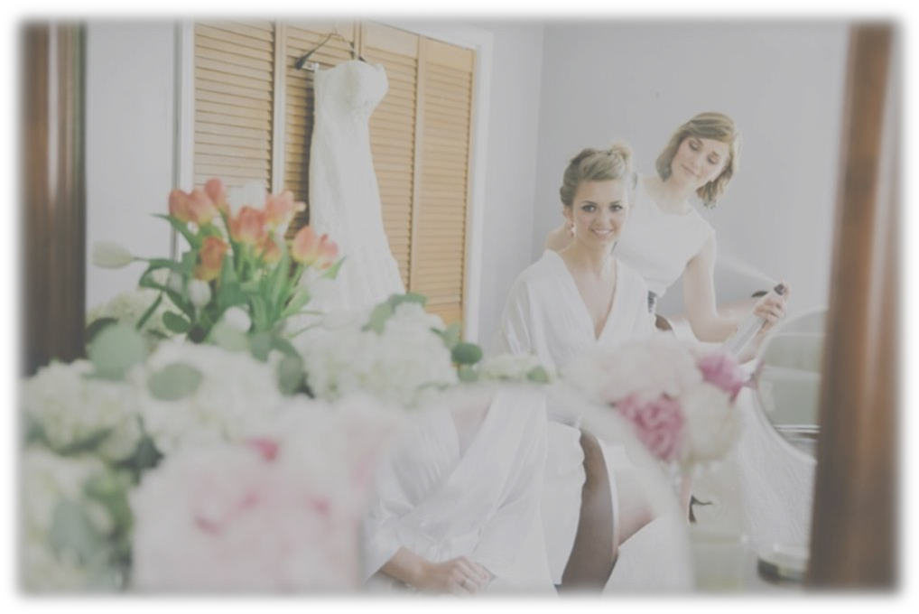

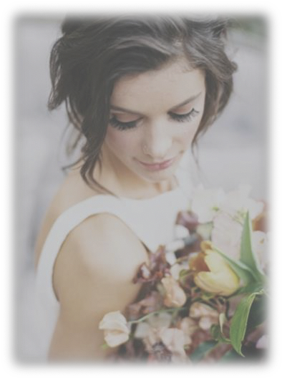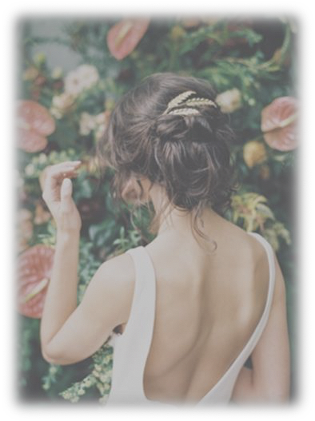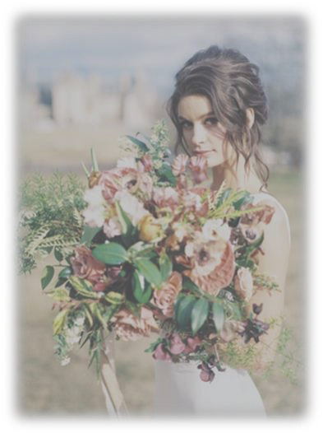

DO YOU HAVE A STUDIO LOCATION?

Yes! I am located at 290 Haywood Road Unit 102, Asheville, NC 28806.

IS THE HAIR TRIAL IN THE STUDIO OR ON-LOCATION?

Either! Depending on your comfort and convenience, I am happy to schedule a trial for you in the studio or on location. The hair trial is an additional fee and is **not** included in the bridal hairstyling fee.

WHAT IS INCLUDED IN THE TRIAL?

Each service provides an hour and a half to consult, complete and photograph to ensure you are pleased and feel confident with your final look.

WHEN SHOULD I SCHEDULE MY TRIAL?

My professional recommendation is to schedule the trial (depending on availability) for your engagement photo shoot, any special occasion, or as close as possible to your big day due to possible and unexpected last-minute modifications in style, hair accessories and/or weather. I advise booking your trial as soon as possible if you want a specific date because my clients book appointments a year in advance.

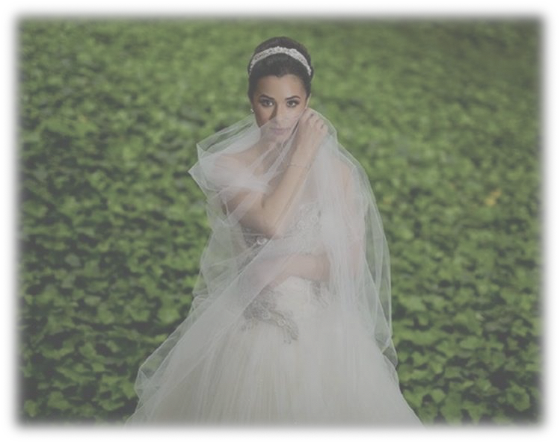

WHAT SHOULD I BRING TO THE TRIAL?

Inspiration: photos and/or Pinterest board.  
Hair accessories: hair extensions, veil, flowers, combs (preferably metal) and/or jewelry.  
A loved one: someone who knows you and opinion you trust.

WHAT IF MY HAIR DOESN’T HOLD CURL?

Thankfully, products have advanced to help secure your curls. I recommend a hair trial to asses if extensions would be sufficient to aide in curl retention or substitute curls for an up-do. In most cases, extensions and/or hair product work miracles.

DO I NEED EXTENSIONS?

It will depend on the desired hairstyle and the texture of your hair. If extensions are recommended and/or required to replicate your dream look, I will let you know.  
*\*I could either order the extensions for you or refer you to a local business.*

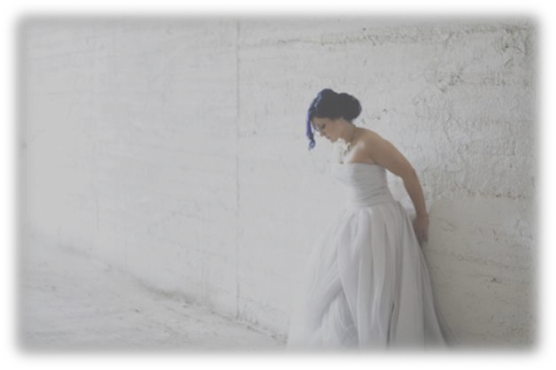

WHAT TYPE OF EXTENSIONS WOULD I NEED?

Depending on the style you select, the type of extensions will vary from gluing in wefts, tape-in, clip-in or a halo. I would be happy to discuss extensions in further detail at the trial

\**a separate fee from the event day hairstyling.*

HOW MUCH DO THE EXTENSIONS COST?

Extension prices start from $25 for a weft up to $400 for a halo. Together, we can discuss the best option to achieve your dream style.

WHAT IF I ALREADY HAVE EXTENSIONS?

Perfect! One step less for me.

HOW LONG IS EACH SERVICE?

Bridal hair: an hour and a half

Bridal makeup: an hour and a half

Bridal party hair: forty-five minutes

Bridal party makeup: forty-five minutes

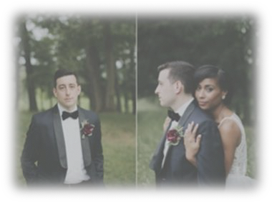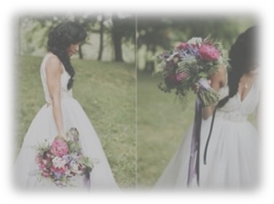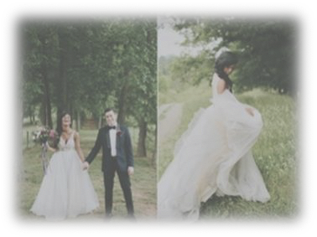

DO YOU REALLY NEED A FULL HOUR AND A HALF FOR MY SERVICES?

No, but in my experience, you will not have a full uninterrupted hour to complete your service. The extra half hour is to allow time to pause for hugs and answering questions without feeling the pressure of being rushed.

HOW DIRTY SHOULD MY HAIR BE?

The most ideal is to have one night slept on hair unless you wash your hair daily. Wash and blow-dry your hair the day before my arrival unless a blow-out and curls is the desired style on your special day.

WHAT IF I HAVE A LARGE PARTY AND NEED MORE STYLISTS?

I am able to reserve additional stylists to complete your bridal parties services within your time-frame for an additional fee of $75 per stylist.

IS THERE A PRICE DIFFERENCE FOR SHORT HAIR?

No. Similarly to long hair, short hair requires an equivalent amount of time and attention to detail.

DO YOU HAVE A MINIMUM REQUIREMENT?

A minimum of $300 is required to reserve beauty services for your day. If you are the only one requiring my skills for hair, makeup and/or hair and makeup, your total fee for the agreed upon services will be $300.

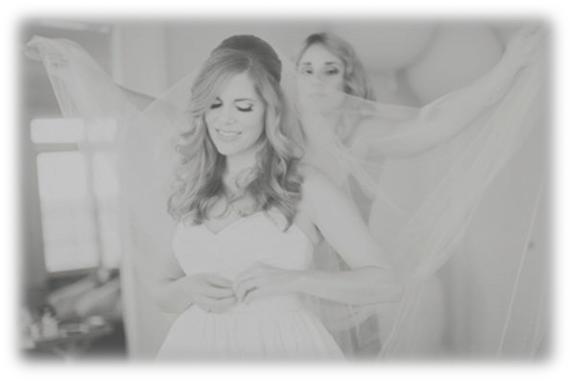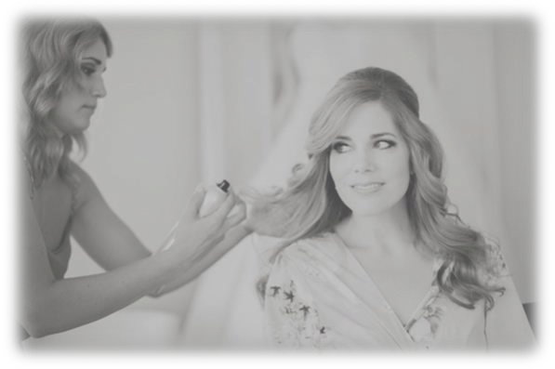

MAY I MAKE CHANGES TO THE SERVICE AGREEMENT?

You may make changes a month prior to your reserved date as long as there is sufficient time on the schedule to complete the services with the required timing per the individual’s requested service.

IS THERE AN ADDITIONAL TRAVEL FEE?

An hour of travel from the salon to your location is included in your fee. An additional $50 per hour will be charged if I am required to travel over an hour.

WHAT IS REQUIRED TO RESERVE YOUR SERVICES FOR MY DATE?

A non-refundable retaining fee of $50 and a signed, completed service agreement is required to reserve the requested date within 48 hours of receiving the documents. The date will not be reserved until both actions are completed!

WHAT FORM OF PAYMENTS DO YOU ACCEPT?

I accept cash, venmo, square cash and all major credit cards.  
Visa, Master Card, Discover and American Express.  
I apologize for the inconvenience, but I cannot accept payments via checks.

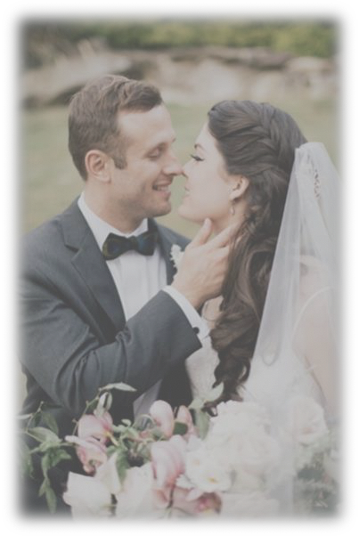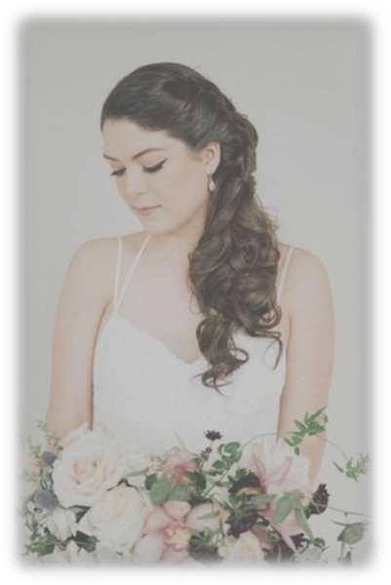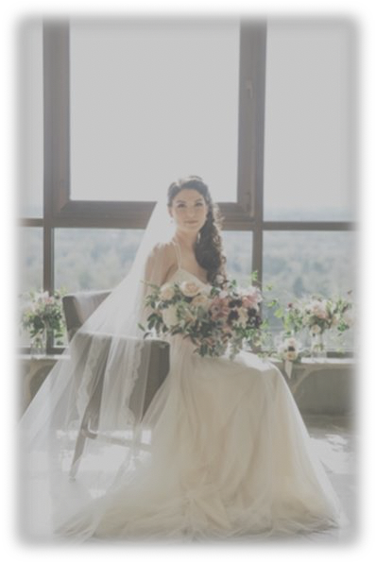

WHAT IF I HAVE AN EARLY START TIME?

An additional fee of $75 per hour before 9 AM start time will be added to the final fee to accommodate an early start.

WHEN DO I PAY YOU FOR THE AGREED UPON SERVICES?

I send an invoice securely via Square with the final balance minus the retaining fee a week prior to the date. According to the service agreement, you are responsible for the full payment prior to my arrival. Customarily, brides collect payments from individuals to finalize the payment.

\**Payment must be made a week prior to the event date.*

If you have any further questions

(828) 713-6921

z@salonzhenya.com

[salonzhenyya.com](https://www.salonzhenya.com/)

instagram.com/salonzhenya

facebook.com/zhenya.lazarchuk